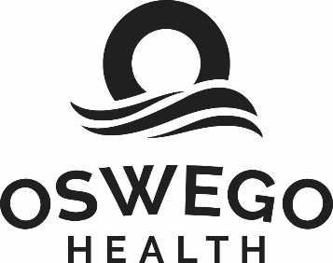
FOR IMMEDIATE RELEASE Contact: Jamie Leszczynski
(315) 349-5601
jleszczynski@oswegohealth.org

Oswego Health Welcomes Johna Halko, PA-C to the Center for Gastroenterology & Metabolic Diseases
(Oswego, NY – April 3, 2023) Oswego Health welcomes Johna Halko, PA-C to the healthcare system as a new Physician Assistant at the Center for Gastroenterology & Metabolic Diseases.
Halko earned her Physician Assistant Master of Science in 2022 and her Bachelor of Science in Medical Studies in 2021 from DeSales University.
Throughout her training, Halko had clinical rotations in family medicine, general surgery, emergency medicine, psychiatry, pediatrics, OB/GYN, and internal medicine, however, her passion has always been in gastroenterology. In particular, during her gastroenterology elective, Halko focused on coordinating patient care between the gastroenterology and primary care teams and assisted in the development of targeted patient education materials on preventative measures for patients impacted by complex gastroenterology issues.

Halko joins the Center for Gastroenterology & Metabolic Diseases and will work alongside Mohammad Fahad Ali, MD, Ajoy Roy, MD, Suri Karthikeyan, MD, and Rewati Bhattarai, MSN NP-C, to offer the highest quality of care for a wide spectrum of diseases and disorders affecting the gastrointestinal (GI) tract, which includes the esophagus, stomach, liver, gallbladder, bile ducts, pancreas, intestines, colon, and rectum.

###

About Oswego Health:
The mission of Oswego Health is to provide accessible, quality care and improve the health of residents throughout the community. As a nonprofit healthcare system established in 1881, Oswego Health is proud to continue to be one of Oswego County’s largest employers. More than 1,200 employees spread throughout its 17 locations, work for the Oswego Health system, which includes the 132-bed community Oswego Hospital, a 32-bed psychiatric acute-care facility with multiple outpatient behavioral health service locations, The Manor at Seneca Hill, a 120-bed skilled nursing facility, and Springside at Seneca Hill, an independent retirement community. The health system also operates Oswego Health Home Care, the only hospital-based certified home healthcare agency in the County as well as two outpatient centers, including the Fulton Medical Center, offering urgent care, lab, medical imaging, physical therapy, and occupational health services, and the Central Square Medical Center, offering urgent care, lab, medical imaging, and physical therapy services. In addition, Oswego Health includes the Oswego Health captive professional corporation, Physician Care P.C., providing physician services in orthopedics, cardiology, ENT, gastroenterology, breast care, audiology, general surgery, bariatrics, and primary care. For more information about Oswego Health, please visit our website at www.oswegohealth.org.

